רחוב בנאפולי, במונטה די דיו

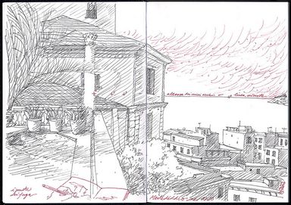

רישום של מונטה די דיו
Monte di Dio
Napoli. La lezione di prospettiva è più sopportabile, disegnando da posti così.
A lesson of perspective is less tough from here, what a view!
By schizzinosasimo capecchi
This photo was taken on November 10, 2010in S.ferdinando, Naples, CM, IT.

עטיפת הספר באיטלקית

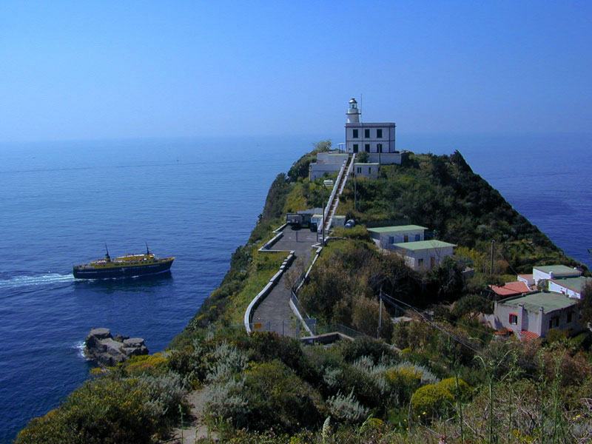
הר הגעש שבסמוך לנאפולי - the Solfatara

At the Solfatara, near Pozzuoli, it is possible to see a crater of boiling lava from close up, with its vapors and steaming muds. This active volcano can be visited and represents one of the main attractions of Campi Flegrei. It is surrounded by a disturbing atmosphere: the earth tormented by fire creates a surreal scenery with unimaginable colors.
Born almost 4,000 years ago in the middle of Campi Flegrei, the Solfatara (from late Latin Sulpha Terra, that is "sulfur land") is characterized by lively fumaroles, sources of gas and mineral water, spouts of hot mud, and earthquakes.
The largest fumarole is Bocca Grande, a natural source of steam under pressure, gushing out at 160°C and consisting of various gases giving the air the characteristic smell of "rotten eggs".

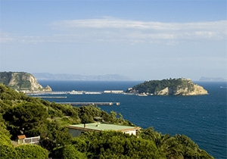
Pozzuoli
Beyond the borders of Naples, there is the town of Pozzuoli, rich in history, culture, and nature.
Nature gave Pozzuoli extraordinary landscapes. You can admire here very particular natural phenomena like solfatara and bradyseism. Even time has been generous preserving until now a submerged town, a subterranean town whose passages intertwine in a labyrinth of streets and alleys giving the opportunity to go over the everyday life of the past.
And here, among ancient ruins, among the alleys of rione Terra, in a town where each stone has its story and a past to tell, the challenge of technological innovation presents itself as a thin thread between past and future.

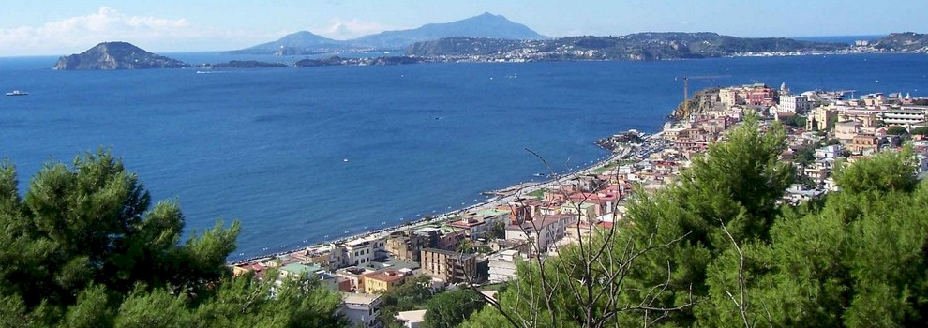

פוצואולי - העיר העתיקה של נאפולי

